Code Smells Element 1 – Long Parameter List

This code smells occurs when there is a function with a long list of parameters.

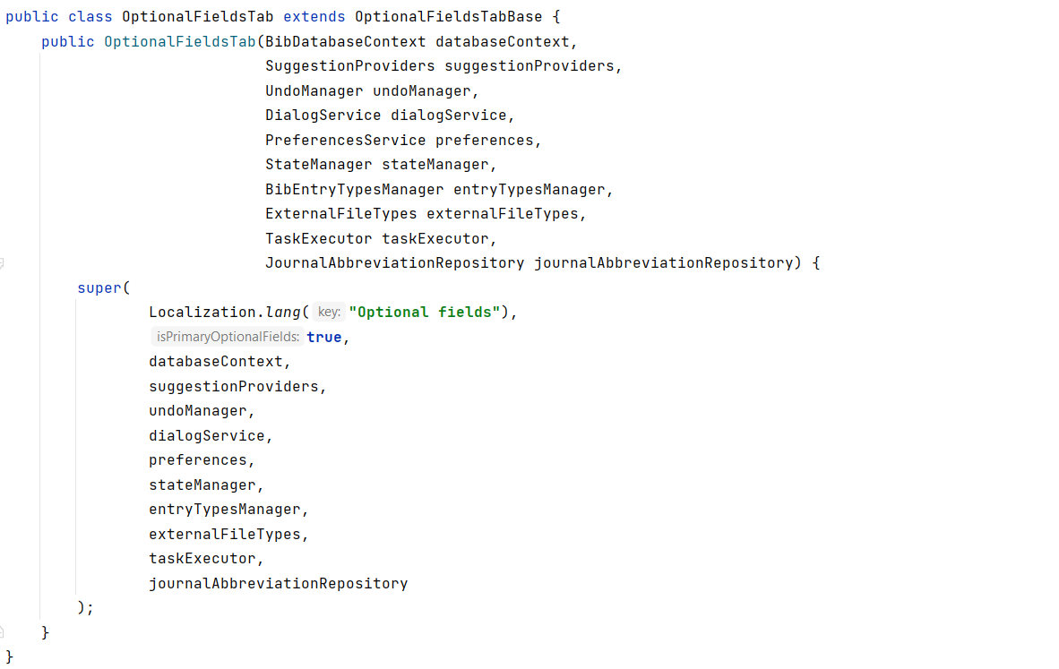**Code Snippet**

**Code Location**

The path where this code smells is found (class path):

*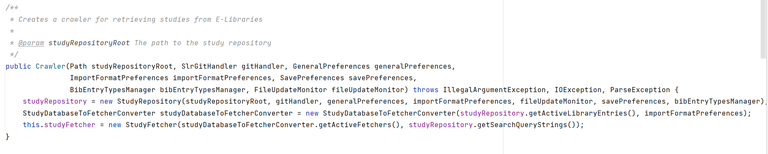“src\main\java\org\jabref\logic\crawler\Crawler.java”*

**Justification**

As it shows above, the constructor Crawler has a long list of parameters, exactly 10 parameters, sometimes having this long parameter list can be difficult to read or use the method.

**Refactoring proposal**

There are a few solutions to this problem. The first solution is to create sub methods to divide the parameters between them. The other solution is to put together some of the parameters with similarities into a new object.